认知神经科学硕士招生
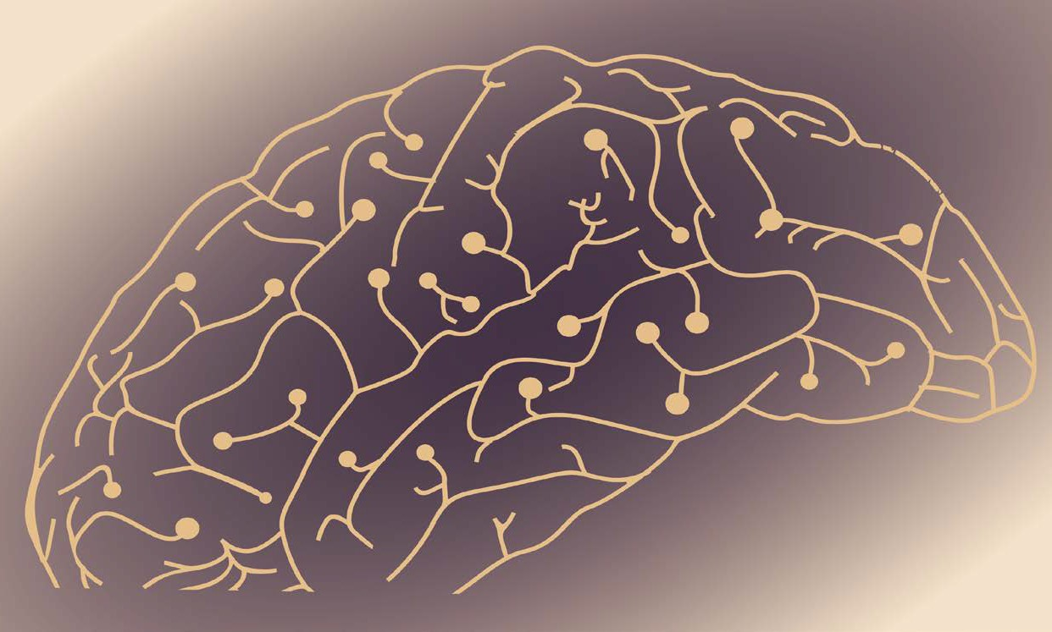
Cognitive Neuroscience Master’s Program Recruitment

推免生接收计划（硕士） - 依托华东师范大学心理与认知科学学院
上海纽约大学神经科学教授兼职在华东师范大学心理与认知科学学院认知神经科学专业招收推免生（硕士）。报考学生必须已经获得就读本科学校推荐免试资格。
有意报考的推免生请在 9 月 20 日前在研究生招生信息网注册账号进行预报名（系统网址:
http://www.yjszs.ecnu.edu.cn/main/index.asp）。详见华东师范大学研究生招生信息网。

招生教授信息请见后页。

ECNU Brain and Cognitive Science Graduate Program Track (MS)
NYU Shanghai Neuroscience faculty are recruiting students into the Master's Program in Cognitive Neuroscience at the School of Psychology and Cognitive Science at East China Normal University. Students are accepted through Chinese National Postgraduate Recommendation System. Applicants who have obtained "the Recommendation Qualification" with their undergraduate institutions (to be exempted from Chinese National Master's Program Entrance Examination) can apply.
Interested students please pre-apply in the ECNU pre-application system at http://www.yjszs.ecnu.edu.cn/main/index.asp by September 20th, 2017. For more information, please check the website of Graduates Enrollment of East China Normal University.

Please find the recruiting faculty information on following pages.

招生教授
Recruiting Faculty

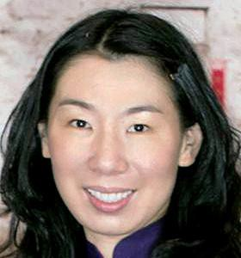
李黎
神经科学和心理学副教授上海纽约大学
电子邮箱：ll114@nyu.edu

网站：

http://shanghai.nyu.edu/research/brain/faculty
/li-li http://www.psychology.hku.hk/percept_act/ind ex.html

李黎教授是上海纽约大学神经科学和心理学副教授。在加入上海纽约大学之前，她曾担任香港大学心理学副教授，及美国航空航天局艾姆斯研究中心人因系统整合研究部门高级研究员。李教授拥有美国布朗大学认知科学博士学位及中国北京大学心理学学士学位，并曾在哈佛大学医学院斯格本斯眼科研究所及眼科学系从事博士后研究。
李黎教授的研究方向包括人类感知及自运动控制、视动控制、手眼协调及虚拟现实。李教授于 2006 年搭建了香港第一个研究视知觉与运动控制的虚拟现实实验室。实验室自成立起至今保持了高效稳定的研究产出，发表了多篇被视为行业经典的文章。李教授是认知研究领域的国际领头科学家，其研究成果被《Psychological Science》、《Journal of Neurophysiology》、《Journal of
Vision》、IEEE 期刊等所收录。李教授同时是 SCI 刊物《Perception》的执行编委和EI 刊物
《Displays》的编委，并担任其特刊《人类视知觉与运动应用性研究》的客座编辑，同时还是 20
家业内国际权威杂志的审稿人。
李黎教授具有杰出的优异基金申请记录，自 2006 年加入香港大学起申请基金成功率为
100%，是香港最高等的研究基金—香港教资会研究资助局优配研究金同时期最成功的申请者之一，也是香港大学人文社科学院同时期获得政府基金支持最多的研究者。李教授在认知研究领域具有很高的国际声望，迄今为止已经组织并主持了多次国际学术交流研习会，其中包括亚太地区最大的视觉会议。
李黎教授的贡献不仅只限于学术，同时还具有高度的为学生以及所在大学服务的精神。李教授多年来一直担任多个本科生及成人教育专业的督导主席，并于 2010-2011 年主持了香港大学心理系网页的重建以及心理系系徽的设计。

Li Li
Associate Professor of Neural Science and Psychology
NYU Shanghai
Email: ll114@nyu.edu

Website: http://shanghai.nyu.edu/research/brain/faculty
/li-li http://www.psychology.hku.hk/percept_act/ind ex.html

Li Li is an Associate Professor of Neural Science and Psychology at NYU Shanghai. She received her B.S. degree in psychology from Peking University (Beijing, China) and her Ph.D. degree in cognitive science from Brown University (Providence, RI).
After a postdoctoral fellowship at the Schepens Eye Research Institute and the Department of Ophthalmology at Harvard Medical School (Boston, MA), she worked as a senior research associate in the Human Systems Integration Division at NASA Ames Research Center. She was an associate professor in Psychology at the University of Hong Kong before moving to NYU Shanghai.
Professor Li’s research interests include human perception and control of self-motion, visuomotor control, eye-hand coordination, and virtual reality. Her work has appeared in Psychological Science, Journal of Neurophysiology, Journal of Vision, and IEEE journals.
Professor Li is an Action Editor for Perception and i-Perception (Sage) and on the Editorial Board of Displays (Elsevier).

Education
- B.S., Psychology, Peking University, 1992
- M.A., Cognitive Psychology, Stony Brook University, 1995
- Ph.D., Cognitive Science, Brown, 1999

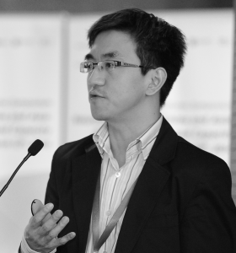
蔡昕颖
神经与认知科学助理教授上海纽约大学
电子邮箱: xinying.cai@nyu.edu

网站：
http://shanghai.nyu.edu/research/brain/faculty
/xinying-cai neuro.shanghai.nyu.edu/cai_lab

蔡昕颖现为上海纽约大学神经与认知科学终身制资格助理教授。他是华东师范大学-纽约大学脑与认知科学联合研究中心（上海纽约大学）的核心成员，也是纽约大学神经科学中心和跨学科决策研究所的成员。拥有浙江大学控制科学与工程学学士学位和亚利桑那州立大学生物工程学博士学位。
蔡教授目前的研究领域为经济抉择行为的神经性基础，即神经经济学。蔡教授先后在《神经元》、《神经科学杂志》、《自然－神经科学》和《科学》等国际顶尖学术期刊上发表了研究成果。加入上海纽约大学前，蔡教授分别在耶鲁大学和圣路易斯华盛顿大学从事博士后研究工作。
在美国电气电子工程师学会第二届神经工程学国际大会上，蔡教授被授予神经工程学杰出研究成果奖。

教育背景
- 2007 年：亚利桑那州立大学，生物工程学博士
- 1999 年：浙江大学，控制科学与工程学学士

研究方向
- 经济抉择的神经机制
- 脑前额叶皮层－基底神经节环路的神经精神病病理

Xinying Cai
Assistant Professor of Neural and Cognitive Sciences
NYU Shanghai
Email: xinying.cai@nyu.edu

Website: http://shanghai.nyu.edu/research/brain/faculty
/xinying-cai neuro.shanghai.nyu.edu/cai_lab

Xinying Cai is an Assistant Professor of Neural and Cognitive Sciences at NYU Shanghai. He is a core faculty at the NYU-ECNU Institute of Brain and Cognitive Science at NYU Shanghai and an associate member at the Center for Neural Science at NYU’s campus in New York City. He is also a member of the Institute for the Interdisciplinary Study of Decision Making (IISDM). He holds a Ph.D. from Arizona State University and a B.S. from Zhejiang University.
Professor Cai’s current research focuses on elucidating the neural underpinnings of economic decision making (a.k.a. Neuroeconomics). His work has appeared in leading scientiﬁc journals such as Neuron, Journal of Neuroscience, Science and Nature Neuroscience. Prior to joining NYU Shanghai, Professor Cai was a postdoctoral fellow ﬁrst at Yale University then at Washington University in St. Louis. He was the recipient of the Excellence in Neural Engineering Award at the Second Institute of Electrical and Electronics Engineers (IEEE) International Conference on Neural Engineering.

Education
- Ph.D., Bioengineering, Arizona State University, 2007
- B.S., Control Science and Engineering, Zhejiang University, 1999

Research Interests
- Neural mechanisms of economic decision-making
- Neuropsychiatry of the prefrontal-basal ganglia loops

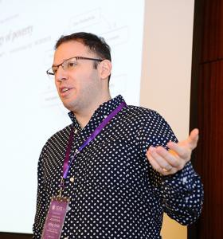
诚杰Jeffrey Erlich
神经与认知科学助理教授上海纽约大学
电子邮箱：jerlich@nyu.edu

网站：
http://shanghai.nyu.edu/research/brain/faculty
/jeffrey-erlich http://neuro.shanghai.nyu.edu/erlich_lab

诚杰（Jeffrey Erlich）毕业于加拿大麦吉尔大学，获得纽约大学博士学位。之后曾任普林斯顿大学副研究员，现任上海纽约大学神经与认知科学助理教授。
Erlich 教授的研究领域主要为决策、注意力及情感的神经机制，其研究成果被《普通神经病学档案》、《神经科学前沿》、《神经元》、《自然》等期刊所收录。
Erlich 教授的科研长期目标在于了解内部环路动态活动及外部感觉输入引发的混沌神经活动如何输出相干行为。动物接受大量感觉输入，并需要在众多相互竞争的目标和驱动因素中做出选
择。如果我们的注意力和行动与外部世界一样混乱（注意力缺失症或许正是如此），我们将难以实现自身目标。大脑如何处理此类竞争性输入信息？如何处理模糊或矛盾的感觉信息？不同的脑区又是如何互相交流、影响和竞争，从而确保通过此类竞争产生连贯一致的思想和行动？这些问题涉及一系列主题：注意力、情感、决策、认知控制、规划、工作记忆等等。为解答此类难题， 实验室通过高通量行为学训练设备，建立了啮齿类动物复杂的、能够激起某些冲突竞争的行为范式。随后，我们综合采用最新的实验技术手段（多通道记录、光遗传学，药理学）和计算模型， 发展并测试相应神经机制方面的理论。
Erlich 教授前往上海纽约大学任职前，已在神经科学领域有长期且广泛的研究经历。作为本科生研究助理时，他以死后人脑组织为标本，从神经化学的角度研究了精神分裂症、阿兹海默病和帕金森病，并且发表了研究成果。攻读博士期间，他与纽约大学的 Joseph LeDoux 合作，研究了大鼠的杏仁核和内侧前额叶皮层在恐惧调节过程中发挥的作用。在普林斯顿大学的Carlos Brody 实验室做博后期间，建立了若干种大鼠新异复杂行为范式，为了解啮齿类动物的额-顶叶的空间-工 作-记忆这一网络活动提供了重要的研究手段。

Jeffrey Erlich
Assistant Professor of Neural and Cognitive Sciences
NYU Shanghai
Email: jerlich@nyu.edu

Website: http://shanghai.nyu.edu/research/brain/faculty
/jeffrey-erlich http://neuro.shanghai.nyu.edu/erlich_lab

Jeffrey Erlich is an Assistant Professor of Neural and Cognitive Sciences at NYU Shanghai. Prior to joining NYU Shanghai, he was an Associate Research Fellow at Princeton University. He holds a Ph.D. from New York University and a B.S. from McGill University in Montreal, Canada.
Professor Erlich’s research interests are neural mechanisms of decision-making, attention and emotion. His work has appeared in Archives of General Psychiatry, Frontiers in Neuroscience, Neuron, and Nature.
The long term goal of Professor Erlich's research is to understand how chaotic neural activity, driven by internal dynamics and external sensory input, is resolved into coherent behavior. Animals have many competing goals and drives as well as a barrage of sensory input to process. If our attention and actions are as frenetic as the world around us (as may be the case in attention deﬁcit disorder) we will have diﬃculty accomplishing our goals. How does the brain deal with all of this competing input? How do brain structures deal with ambiguous or conﬂicting sensory information? And how do diﬀerent brain structures communicate, inﬂuence and compete with each other so that the result of this competition is coherent thought and action? These questions cover a range of topics: attention, emotion, decision- making, cognitive control, planning, working memory, and others. In order to tackle these challenging questions, the lab uses a high-throughput training facility to develop complex rodent behavioral paradigms that evoke some aspect of competition of conﬂict. Then using a synthesis of the latest experimental (high-channel count neural recording, optogentics, pharmacology) and computational techniques we develop and test theories of the corresponding neural mechanisms.
Professor Erlich has had a long and diverse neuroscience career before joining the faculty of NYU Shanghai as an Assistant Professor. As an undergraduate research assistant he published work on the neurochemistry of schizophrenia, Alzheimer's and Parkinson's diseases using post-mortem human brain tissue. For his doctoral work, he examined the contribution of the amygdala and the medial prefrontal cortex if the rat in fear regulation with Joseph LeDoux at New York University. During his postdoctoral work with Carlos Brody at Princeton University, he developed several novel complex behavioral paradigms in the rat which were vital to the characterization of a rodent frontal-parietal spatial-working- memory network.

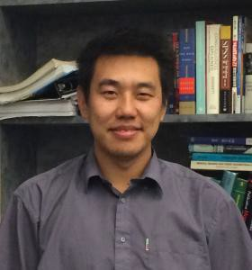
田兴
神经与认知科学助理教授上海纽约大学
电子邮件：xing.tian@nyu.edu

网站：
http://shanghai.nyu.edu/research/brain/faculty
/xing-tian

田兴现任上海纽约大学神经与认知科学助理教授。田兴教授采用电生理学（脑磁图/脑电图/ 颅内脑电）和神经影像学（功能磁共振成像）等前沿技术手段结合行为和计算方法，探查运动感觉整合及互相作用、心象以及言语和语言。他已在神经认知科学领域的专业杂志上发表 SCI 文献十余篇，并且开发了针对脑磁/脑电数据分析的矢量计算工具箱，及创造性的结合心象和语言生成独特的实验范式来探索语言的神经表征。
田兴教授拥有马里兰大学博士学位，任教上海纽约大学前，他曾任纽约大学心理学系博士后研究员。

教育背景与科研经历
- 2009-2014 年：纽约大学心理学系博士后研究员导师：David Poeppel
- 2004-2008 年：马里兰大学认知神经科学博士 导师：David E. Huber,Michael Dougherty
- 1999-2003 年：北京大学物理系学士

研究方向
- 运动及感觉的整合及相互作用
- 语言相关的心理意象
- 语言及言语的神经表征

Xing Tian
Assistant Professor of Neural and Cognitive Sciences
NYU Shanghai
Email: xing.tian@nyu.edu

Website: http://shanghai.nyu.edu/research/brain/faculty
/xing-tian

Xing Tian is an Assistant Professor of Neural and Cognitive Sciences at NYU Shanghai. Using electrophysiological (MEG/EEG), neuroimaging (fMRI) techniques, and behavioral, computational approaches, Professor Tian investigates motor-sensory interactions, mental imagery, and speech and language.
Professor Tian has a Ph.D. from the University of Maryland and, prior to joining NYU Shanghai, he was a postdoctoral fellow in the Department of Psychology at NYU.

Education and Research Experience
- Postdoctoral Research Associate. New York University, Department of Psychology, 2009-2014, Supervisor: David Poeppel
- Ph.D., University of Maryland, Neuroscience and Cognitive Science, 2008, Advisors: David E. Huber and Michael Dougherty
- B.S., Peking University, School of Physics, 2003

Research Interests
Using electrophysiological (MEG/EEG) and neuroimaging (fMRI) techniques with behavioral, Professor Tian uses computational approaches to investigate:
- Motor sensory interaction
- Mental imagery
- Speech and language

详细招生信息请见:

http://neuro.shanghai.nyu.edu/graduate

联系我们：
张怡荦 Yiluo Zhang

电子邮箱：yiluo.zhang@nyu.edu
电话：+86 (0)21 2059-5031

